1.

Table: <https://drive.google.com/drive/folders/0B2O3myu6Z8reajVQSGhrM1AwUkE?usp=sharing>

Datatype:

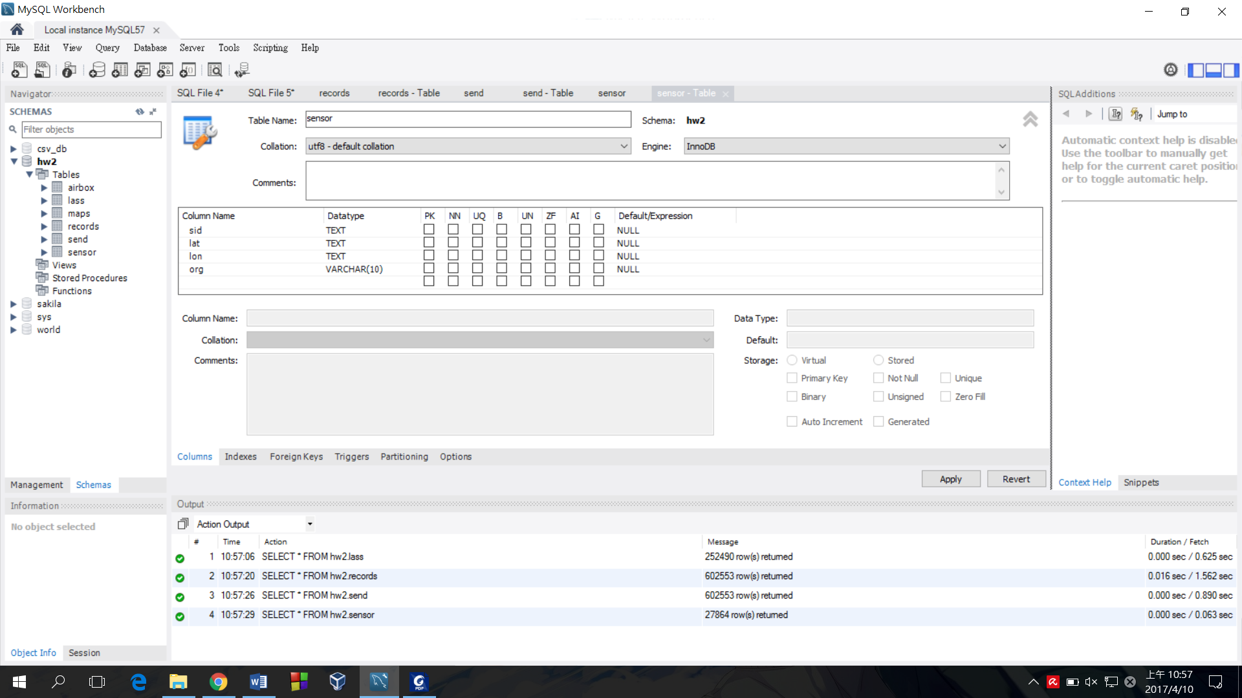

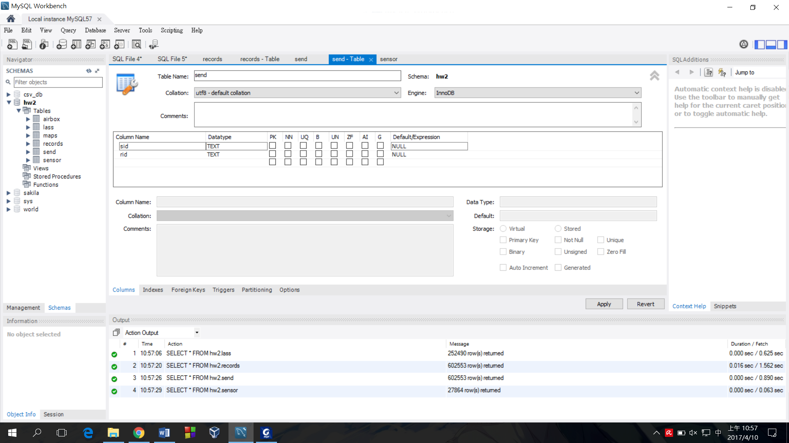

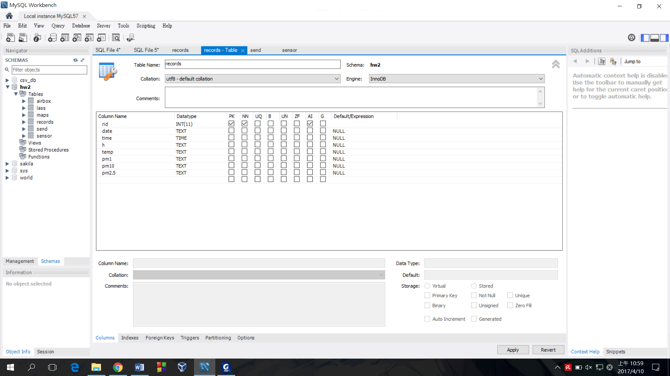

2. Ans: 27864

0.031 sec

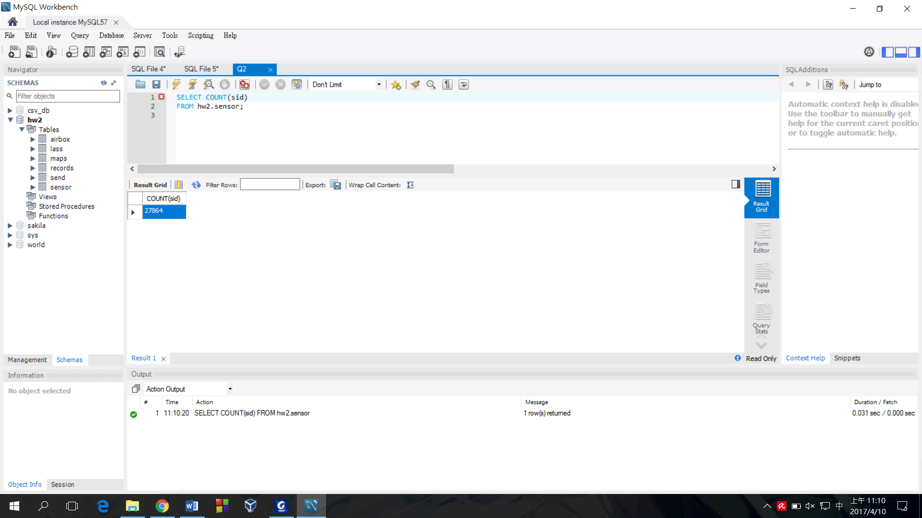

3. Ans: 90

0.656 sec

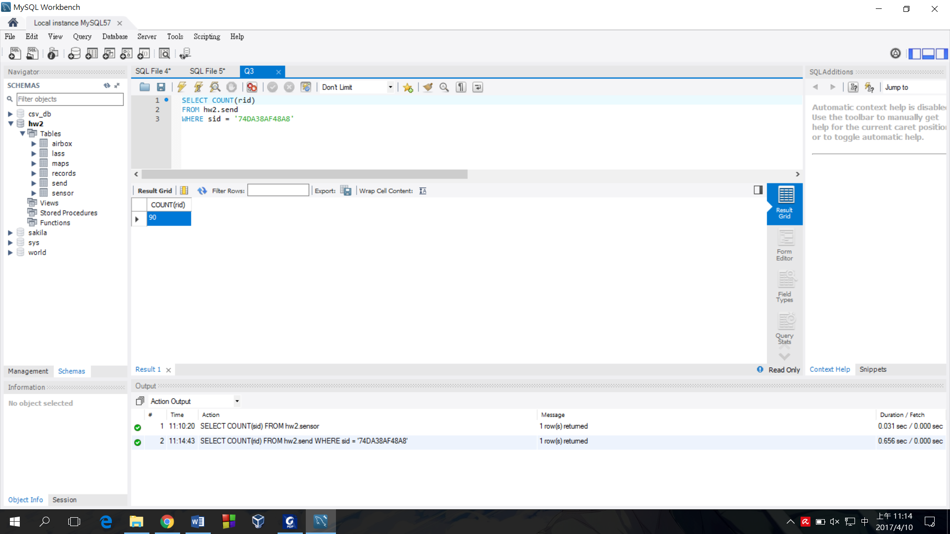



4. Ans: <https://drive.google.com/file/d/0B2O3myu6Z8reT0hMSHZmYjBXRTA/view?usp=sharing>

1.391 sec

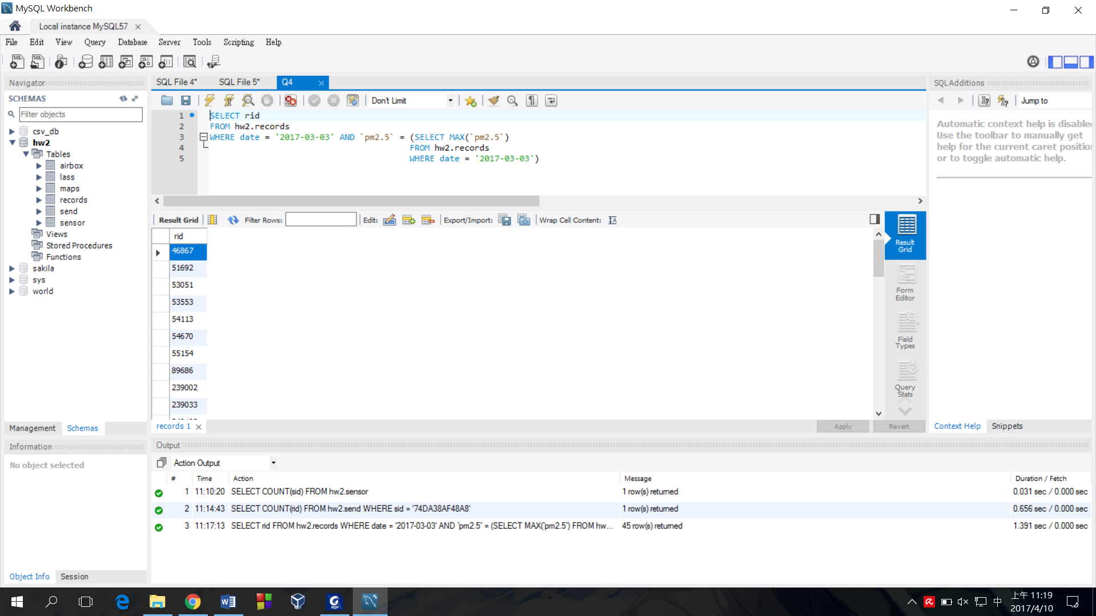

5. Ans: 1.7873 %

0.062 sec

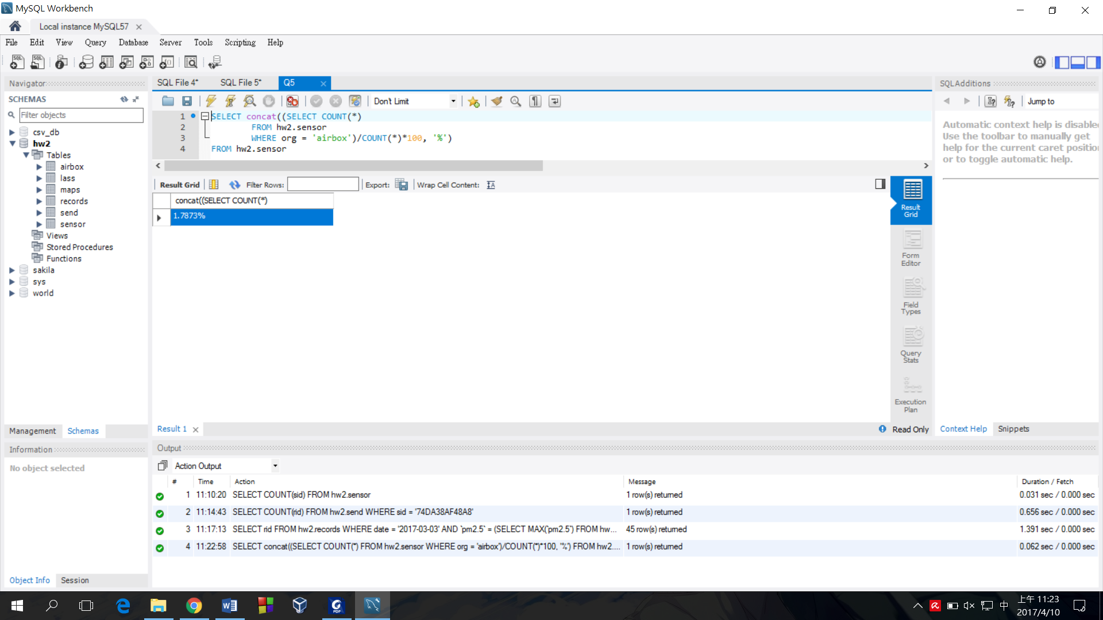



6. Ans: <https://drive.google.com/file/d/0B2O3myu6Z8reTmhXRjhGR01XVEU/view?usp=sharing>

13.094 sec

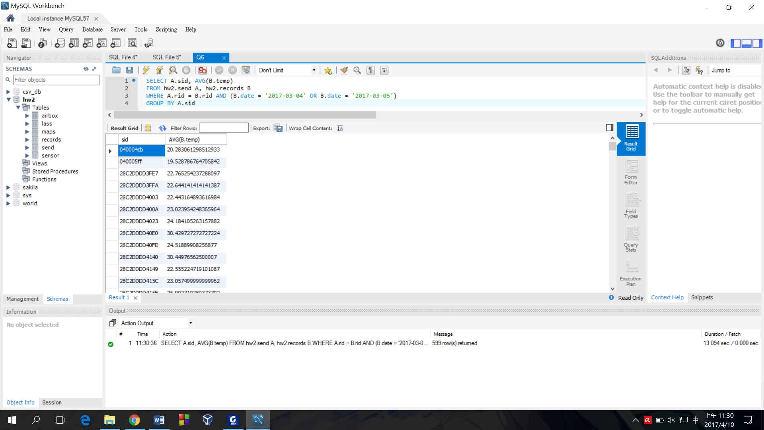



7. Ans: <https://drive.google.com/file/d/0B2O3myu6Z8reM1I0OEhEWUhXejQ/view?usp=sharing>

29.5 sec

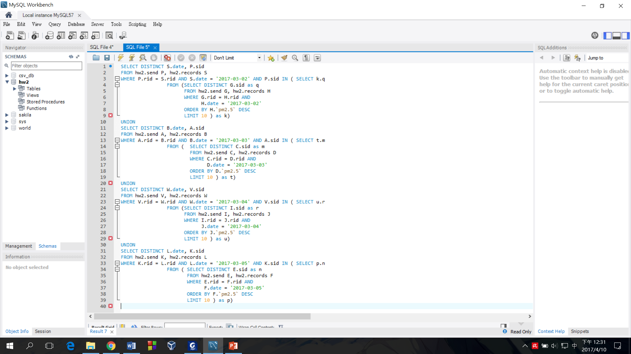

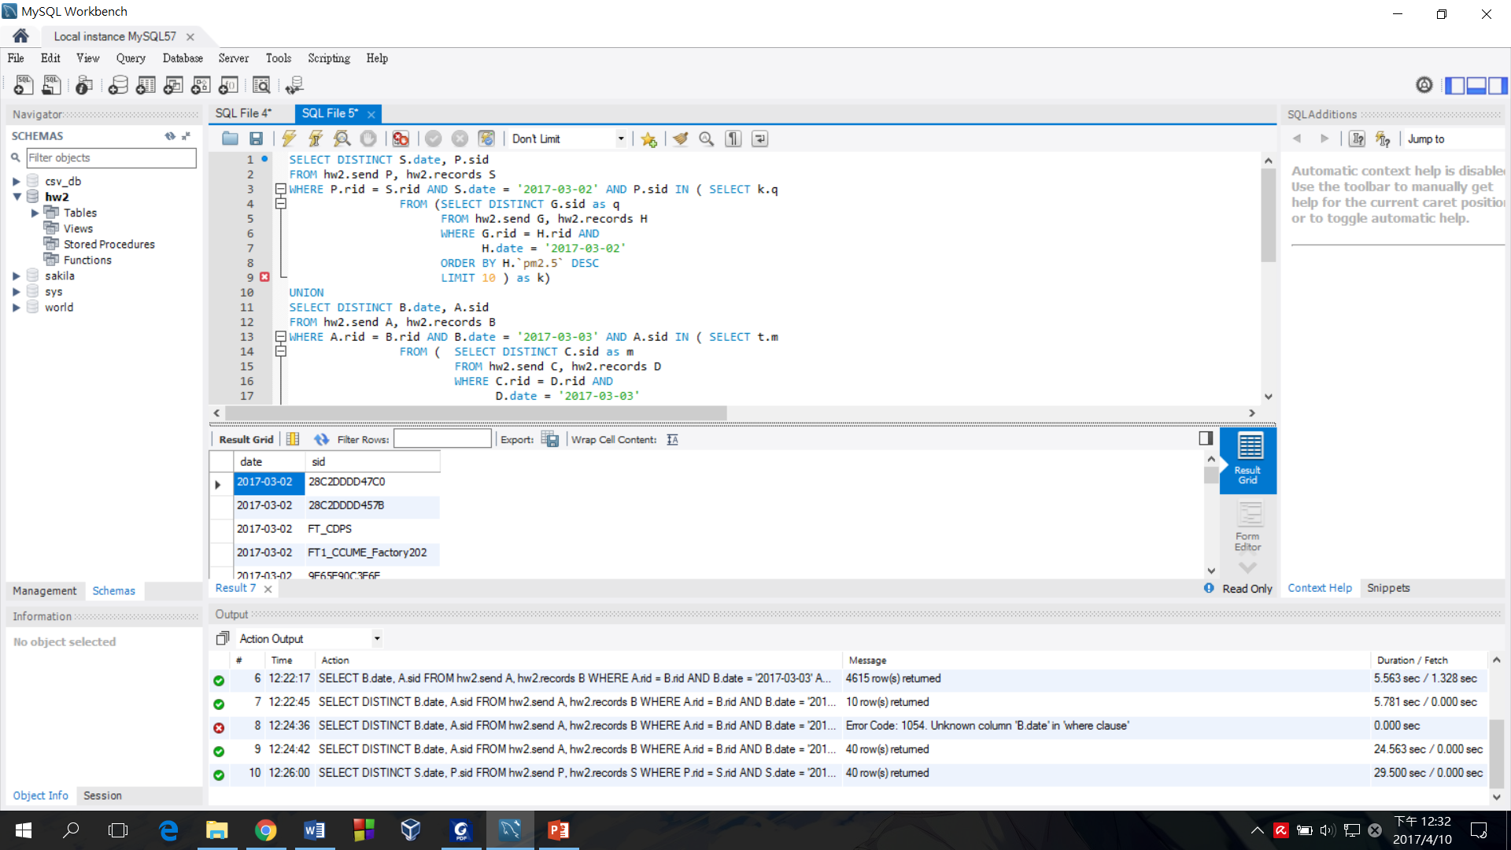



8. Ans: 396.4537 sec

0.687 sec

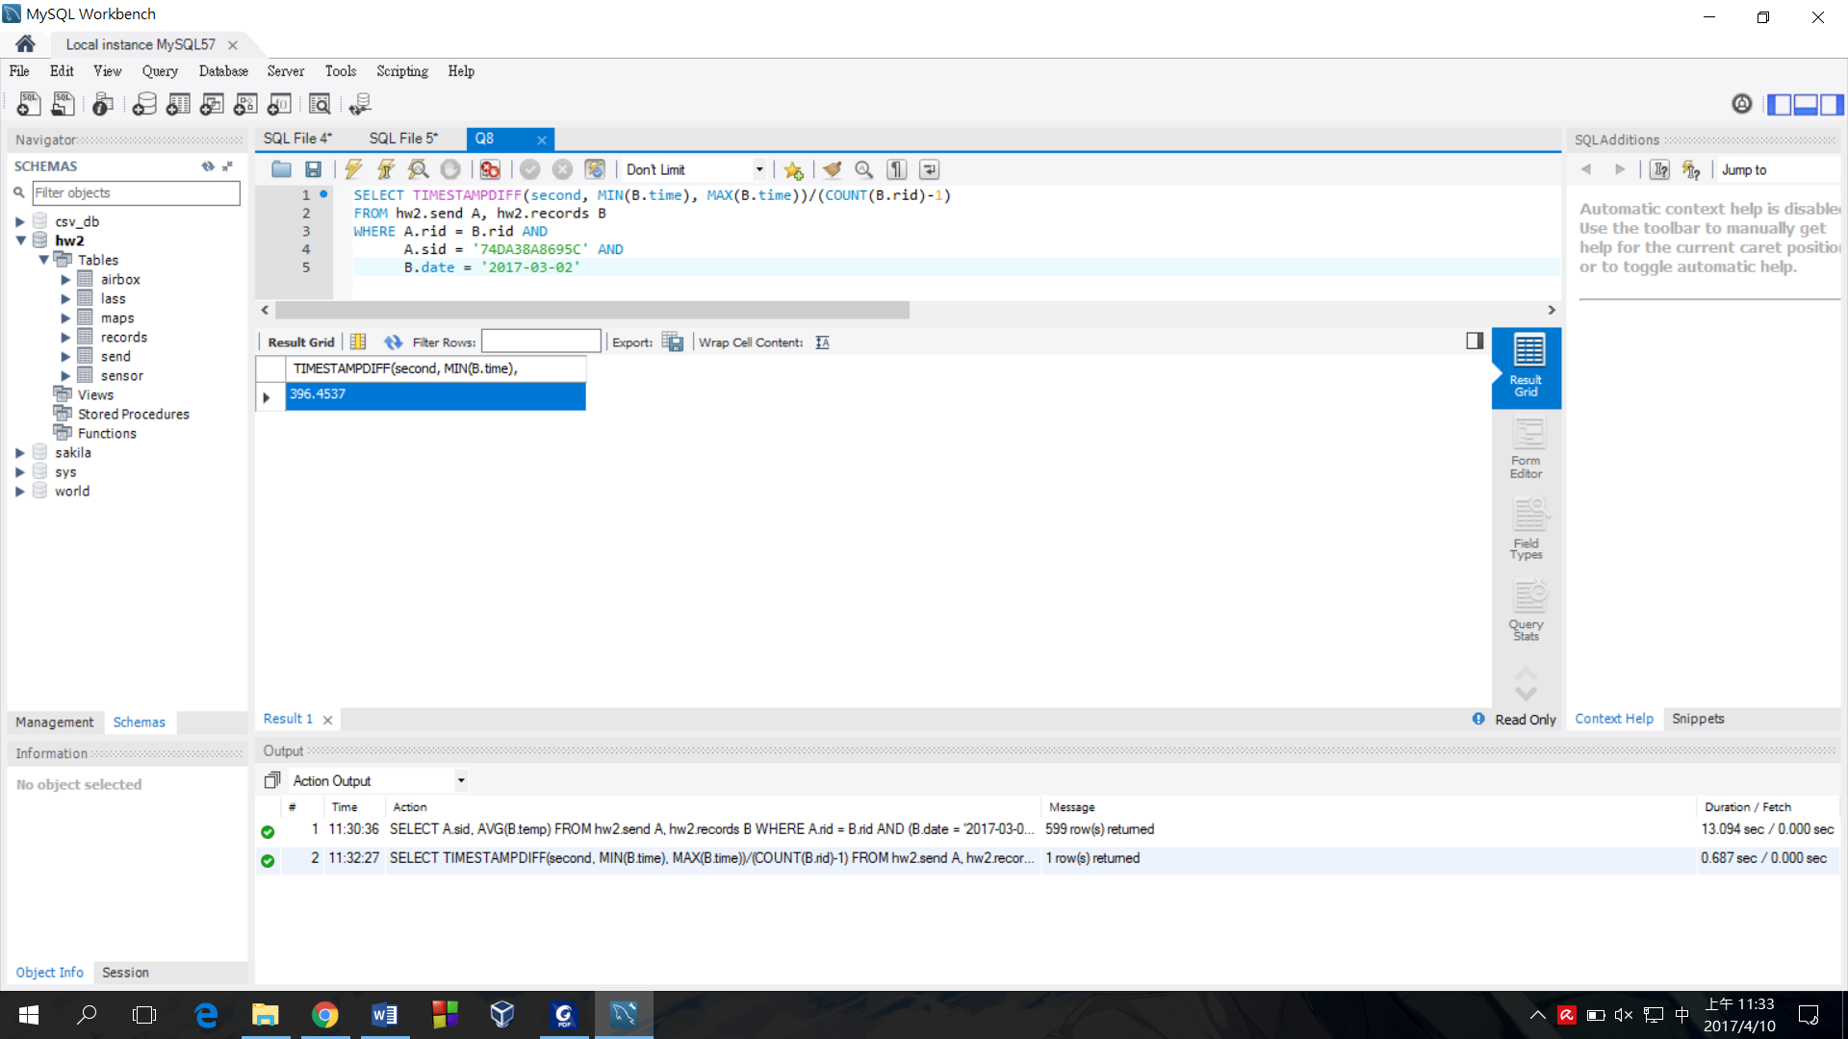



9. Ans: 42398

2.782 sec

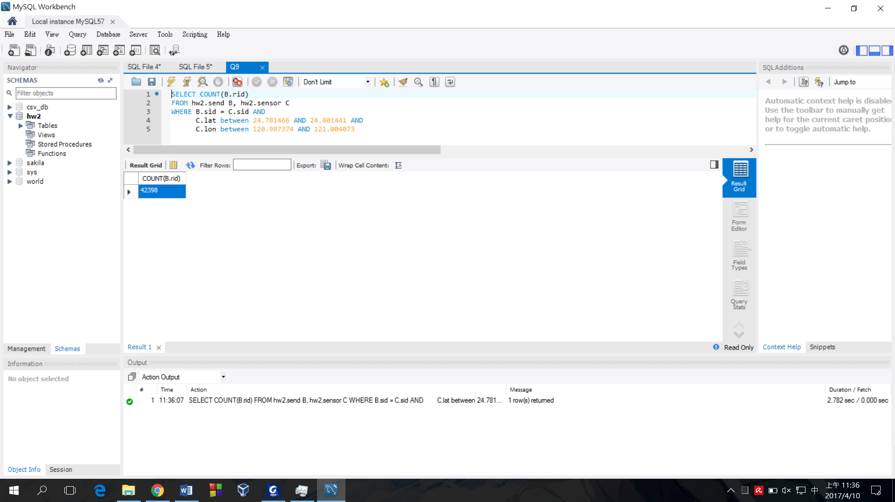





10.